SNOWFLAKE PERFORMANCE MANAGEMENT
In this Doc, I want to give you an idea why and how we do performance tuning in snowflake on overall basis

Why do we need performance tuning in snowflake??
1. We tune the performance of queries for faster execution in snowflake
2. Saving cost

What are the traditional methods to improve performance in relational warehouses?
- Table designs
- Primary keys, indexes
- Table partitioning
- Check query plans
- Hints

What is the difference between traditional partitioning and snowflake partitioning??
Micro partitions will be explained further in exact in upcoming posts
Snowflake automatically leverages the micro partitions to improve performance
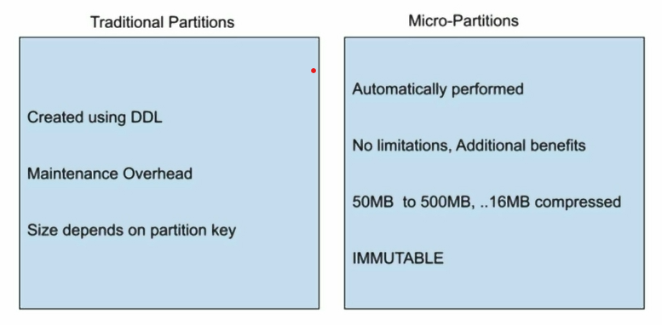

What can snowflake system admins or developers do to improve performance??
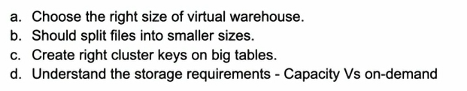
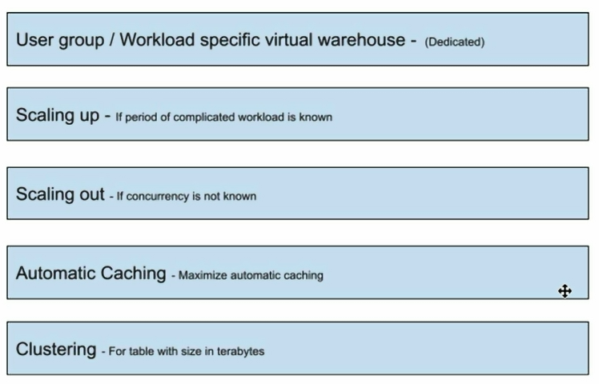
As these 5 steps are covered in detail post by post in snowflake performance management section in upcoming

